Instructions to book in for a “Come and Try” at Pony Club

Use this link to the membership portal of the Pony Club Victoria website
https://osm-pony.omnisportsmanagement.com/Memberships/(S(bg1qxsqh2aoq25y23ffozto4))/OSMMbr_LoginNew.aspx
Click on “Click to Register”.
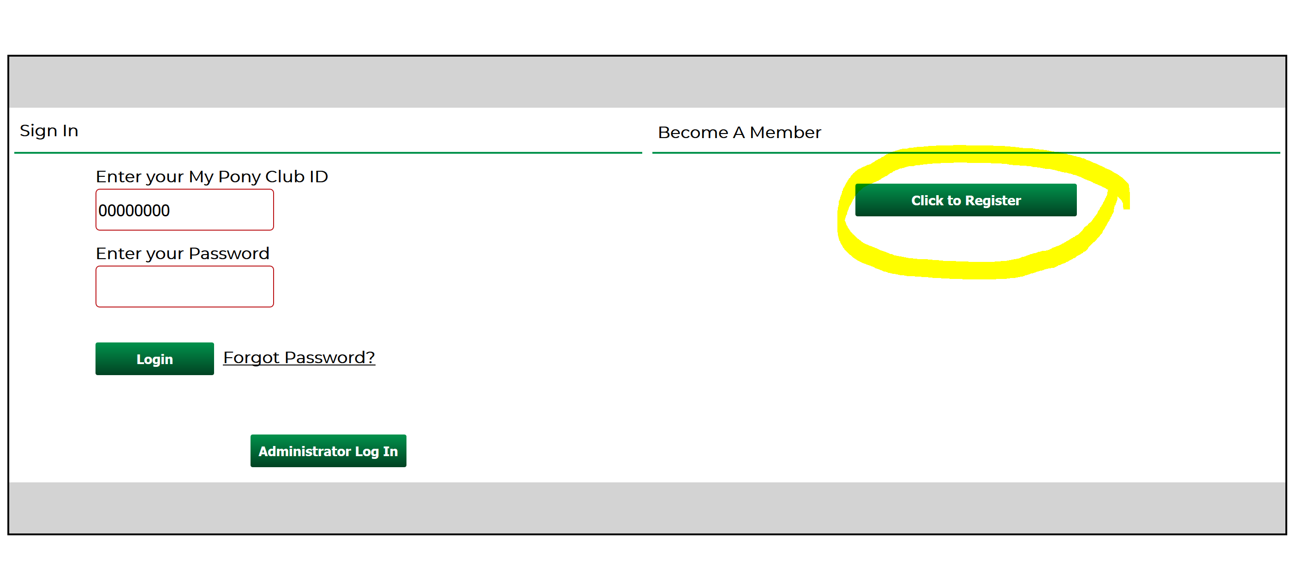

Select from the drop-down menus: Pony Club Victoria, and then Mansfield Pony Club.
Select “Come and Try”

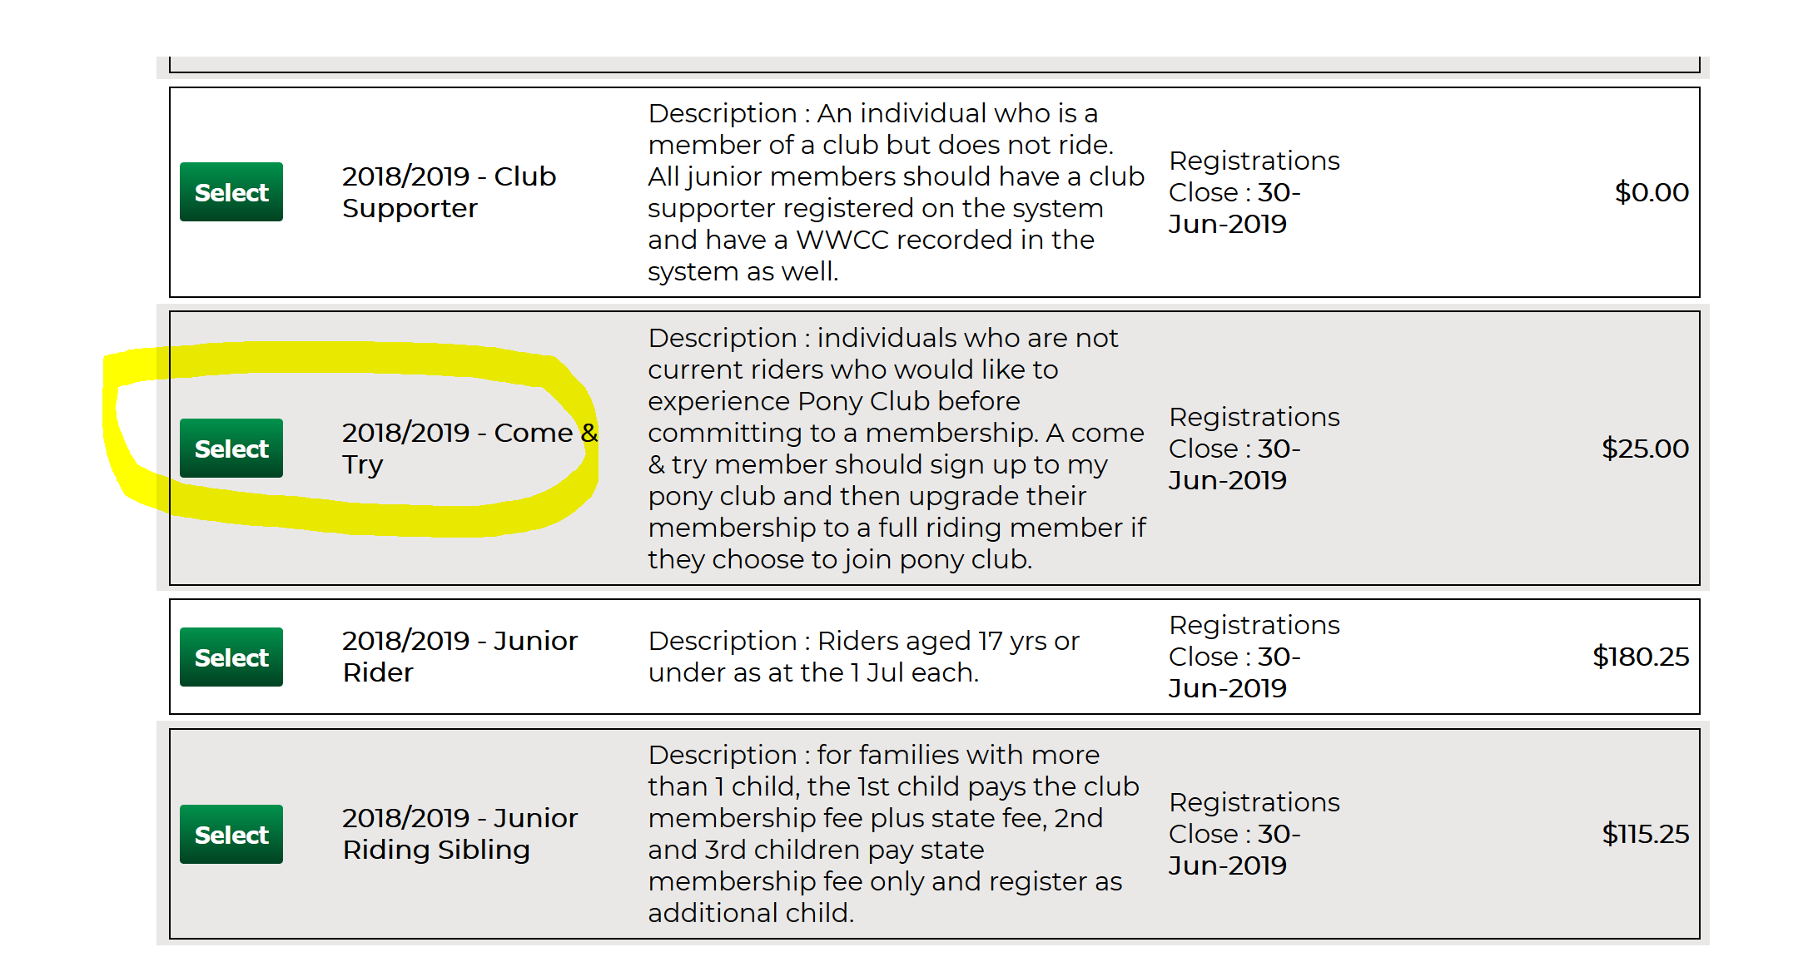
Fill in all the personal details, then click next to answer some questions from PCV, then accept the terms of agreement and privacy policy (if you agree). You will then be asked if you want to buy any merchandise, and then taken to the payment page.
Upon submission of this form, Mansfield Pony Club will be notified of your registration for a Come and Try rally. If you decide to become a member, the cost of the Come and Try will be deducted from your first membership subscription fees.
Please also RSVP to the next rally (or whichever you’d like to attend) by using the Rally RSVP button on the website.
If you have any questions please feel free to contact us or email Mansfieldponyclub@hotmail.com

