Gone Riding

Mansfield Pony Club
Horse Trials
14th & 15th April 2018

The Committee and Members of Mansfield Pony Club would like to extend a warm welcome to all riders and guests to our annual Horse Trials.
We trust you will have a fun weekend, providing you with a wonderful experience, learning and most of all fun!
We would like to thank all our generous sponsors our major sponsor Gone Riding Saddlery. Please pass on a kind thankyou when passing by their trade stand this weekend. Please support and acknowledge where possible all our sponsors.
Thank you to the visitors that have volunteered to assist and our dedicated pony club parents for their contribution to the event, we need all the support we can get to make this event run as smoothly as possible.
We hope you enjoy this competition and return next year.
Enjoy your weekend at the Mansfield Horse Trials.
Please ensure you read the Very Important Competitor notes on the next page to ensure you have a smooth weekend.
This Event is being run under PCAV Horse Trials Rules.
Important Competitors Notes
Secretary’s Office: Office will be open from 5pm Friday afternoon so please feel free to check in early.
Absolutely No Dogs or Pets permitted on the grounds under any circumstances. Penalty of Elimination will be incurred if found on the grounds
Parking & Camping: Camping passes will be issued and need to be displayed on vehicle windscreens. These will be checked, please ensure you have this displayed. (To be collected upon check in) If you haven’t pre-purchased these please email fiona@foxdairies.com.au before the event to organise. You will need one for both Friday and Saturday nights and as per entry the fee is $10 per night camp fee. Parking is at a premium so please be considerate when parking and making yards. STRICTLY NO FIRES
Scratching’s: Please text 0427787490 with name and grade.
Manure: PLEASE PLEASE ensure all manure needs to be removed from around floats & yards and placed in designated Manure Piles around the grounds. Please ensure this happens to enable us to continue running our event! Yard Bonds will be issued after the event providing yards are left clean & empty. Please complete the form at the office to enable bond refund. There will be some wheelbarrows provided. Camp Sites will be inspected before cards are handed back so please save yourself sometime and clean up before handing in your back number!
Numbers: Open Riders are to supply their own number holders. Day Attendance forms need to be completed and handed in with proof of club membership and we will supply printed number inserts. Bridle or saddle blanket numbers may be used for dressage and show jumping.
Cross Country Briefing: This will be held in the scout hall at 8am. Please unsure all clubs have their representative’s there, a list is provided in the program and at the secretary’s office, Thank You.
Gear Check: There will be a compulsory gear Check for ALL phases.
Multiple Rides: Those riders with multiple rides are highlighted. These riders may ride out of order for SJ & XC but must stay within allocated times for each grade. XC preferably in number order over SJ.
Dinner: Pre-Purchased Dinner tickets will be available from the office upon check in, there may be a limited number for those wanting to purchase on the day. However, everyone is welcome to the Karaoke & Auction.
Canteen: Located in the Scout Hall both Saturday & Sunday, Breakfast & Lunch catered for.

Mansfield Pony Club Horse Trials Sponsors 2018
P & E Humphrey Haulauge
For all your bulk Haulage
Contact Paul 0407865974
Contact

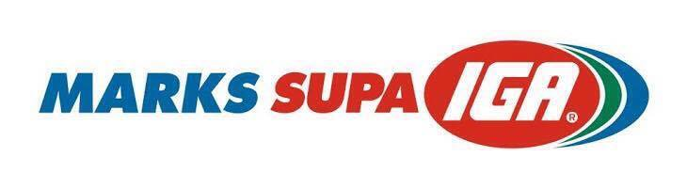 Flaming Pizza’s Mansfield 0428688100

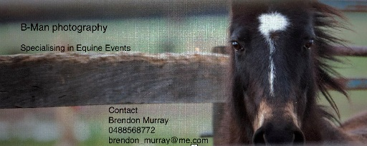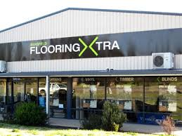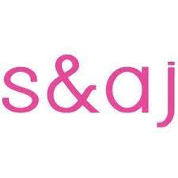
PUMP TECH Mansfield
Brett Stevens 0417303444 Horsepower Saddlery & Pet Supplies45 High St, Mansfield VIC 3722 Pet Warehouse - Shops & Stores – Mansfield

Event Officials 2018
President: Mike Davies
District Commissioner: Lauren Lines
Technical Delegate: Ian Don
Announcer: Emily Humphrey
Ground Jury: Penelope Thomson, Fiona Fox, Ian Don
Coordinators:
Event Secretary: Fiona Fox
Assistant: Rebecca Hutchinson, Sally Hanratty
Dressage: Justine Wedlock
Cross Country: Poss Thomson
Showjumping: Fenella Cameron, Lauren Lines
Gear Check: Nicole Bertalli
Sponsorship: Emily Humphrey, Sophie Fox
Canteen: Anne Payne & Paul Hanratty
Saturday Night Dinner: Hanratty Family
Crash Crrew & Grounds: Mike Davies & Shane Callahan
First Aid: Lauren Nitscke
Veterinary Officer: Dr Penelope Thomson
Official Photographer: B Man Photography
Trophy Rugs: Gone Riding Saddlery

Mansfield Pony Club Horse Trials 2018
Time Table

Saturday Saturday
Dressage
Sand Show jumping
Ring 5 8am-12.00pm Grade 5PC Grade 4 Show jumping
Oval Grade 5 open 2pm-4.30pm

1.45-2pm Course Walk
Ring 4 8am-4.00pm Grade 4A PC 2.30-2.40 Course Walk
Oval Grade 4B PC
Grade 4 Open

Ring 3 8am-11.20 Grade 3A PC
Sand Grade 3B

Ring 2 8am-10.50 Grade 3 Open
Sand

Ring 1 8am-12.30 Grade 2 PC
Sand Grade 2Open
Grade 1 PC
Grade 1 Open

Sunday |  |  |  |  |  | Sunday
Cross Country |  |  |  |  |  | Show jumping
 | 9.00-10.00 | Grade 4 |  |  | 8am | Course Walk
 | 10.20-10.41 | Grade 5 |  |  | 8.30-9.40 | Grade 5
 | 11.15-12.10 | Grade 3 |  |  | 10am | Course Walk Gr2
 | 12.40-1.00 | Grade 2 |  |  | 10.30 11.10 | Grade 2
 | 1.30-1.45 | Grade1 |  |  | 11.3 | Course Walk Gr1
 |  |  |  |  | 12:00-12.15 | Grade1
 |  |  |  |  | 12:30 | Course Walk
 |  |  |  |  | 12.45-2.30 | Grade 3
Dinner & Auction Prizes

Even if you don’t have Dinner Tickets please feel free to join us for our Auction and Kareoke Saturday Night
Auction Items Include:

Betta Electrical: Weber- Q

STK Equine Massage Therapy- voucher- Full Body Treatment value $80

Caroline Brown Horse Clipping- Voucher for Full Body Clip.

S & AJ Gift & Homewares- 2 calf hide stools

Progressive Equine- First Aid Kit value

Bronzed Gunz & Bunz- 4x sessions for Fullbody Spray tan

The Coffee Merchant Mansfield- Stovetop coffee hamper

Horsepower Mansfield- Stock Whip (value $115)

Sadie Powers- Prestige Breastplate (value $299)

Trade Stands
Please visit our trade stands and support them

Gone Riding
Irwin Stock Feeds
Top Fodda
Flaming Pizza
Roaming Poppy
Fibre Fresh

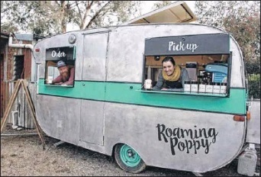

Cross Country Judges
Club | Name
Starter | Gail & Neil O'Halloran
Finish | Michael Lemin & Linda Terry
Vet | Progressive Equine
Vet Penciller | Sen
Outside Judges
 | Julie Walpole
 | Glenys Jacobs
Benalla | 4
Whittlesea | 1
Jingellic | 1
Seymour | 1
Kergunyah | 2
Dandenong Ranges/ Mornington Pen | 1
Seville | 2
Moyhu | 4
Wodonga | 2
Shepparton | 2

